Chapter 16, Problem 21.

In the circuit of Fig. 16.44, the switch moves (make before break switch) from position A to B at t = 0. Find v(t) for all t ≥ 0.

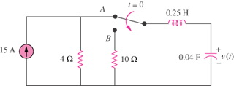

Figure 16.44
For Prob. 16.21.

